Pricing Calculation - Hermes Program

- Base Rate: Read Base Rate from the table below. 6.125% rate has base price 99.75%, and 6.25% Rate has price at par.
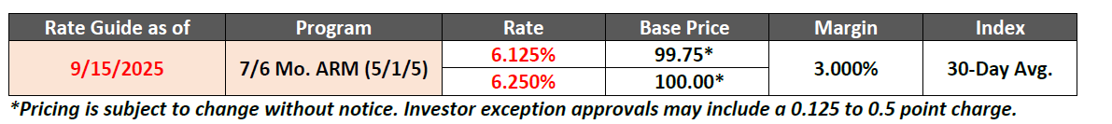
- Rate Adjustment
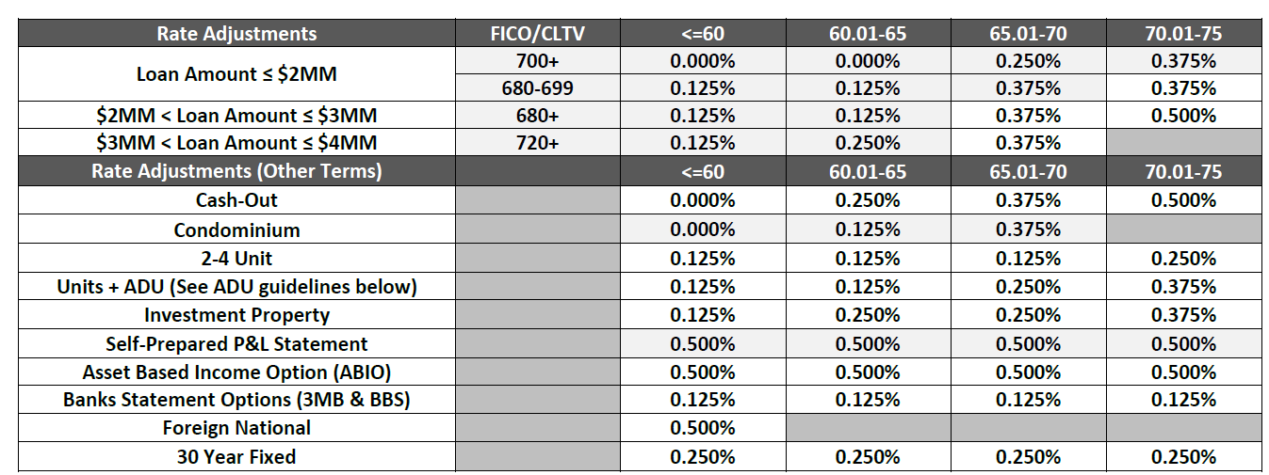

- Loan Amount/FICO: check loan amount, FICO and CLTV (if CLTV is not provided, assume CLTV = LTV or AI asks for more information)
Example:
If Loan amount <=2mm and FICO >=700, LTV <=60, rate adjustment = 0, if LTV is 60.01 to 65%, rate adjustment =0, if LTV is 65.01 to 70%, rate adjustment = 0.25%, if LTV is 70.01 to 75%, rate adjustment = 0.375%

- Cash- Out: if loan purpose = cash out, check LTV and use this table.
Rate Adjustment = Rate Adjustment from 1 +
0%（if LTV <=60%）
0.25% (60.01< =LTV <= 65%)
0.375% if ( 65.01 <=LTV <=70%)
0.5% if (70.01<=LTV <= 75%)

- Condo: check property type and LTV
- Units+ ADU : check units and LTV
- Investment property: check Occupancy and LTV
- Self- Prepared P&L statement: Check Documentation Type and LTV
- Asset Based Income: check documentation type and LTV
- Bank Statement: check documentation type and LTV
- Foreign National: if the borrower is foreign, check LTV
- Loan program: if it’s 30yr fixed, check LTV

- Example:
Loan Amount 2mm, FICO 720, LTV 68%, Cash Out, 2-4 Units, Investment property, Bank Statement, 30 year fixed
Rate Adjustment = 0.25% (Loan Amount/FICO/LTV)
+ 0.375%(Cash Out)
+ 0.125%(2-4 Units)
+ 0.25%(Investment Property)
+ 0.125%(Bank Statement)
+ 0.25%(30 yr fixed)
= 1.375%
Final Rate= Base Rate + Rate Adjustment
Program | Rate | Price
Hermes 7/6 ARM | 7.5% （6.125+1.375） | 99.75
Hermes 7/6 ARM | 7.625% ( 6.25 + 1.375) | 100
- Extension:
AI asks if extension is needed, if so
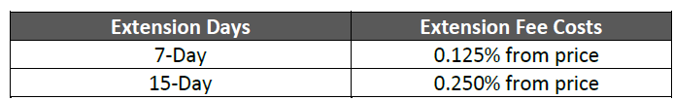

-----------------------------------------------------------------------------------------------------
Mortgage Terms:
- Documentation:
  - Full Doc
  - Bank Statement
  - P&L
  - Asset Based / Asset Utilization
  - 1099
  - WVOE

- Occupancy
  - Primary
  - Investment Property
  - Second Home
  - Vacant

- Loan Purpose:
  - Cash Out
  - Purchase
  - Rate/Term Refi

- Property Type
  - SFR (Single Family Residential)
  - Condo
  - 2-4 units
  - Multi-family 5+ Units

